### Name-:Pratiksha Bahuguna

**SAP ID-:**500105543

**Course**-:B.Tech(C.S.E.),DevOps

**EXPERIMENT 2**

**AIM: Working with Docker (Basic Commands)**

**Steps to Complete:**

1. Search a Redis image on DockerHub  
   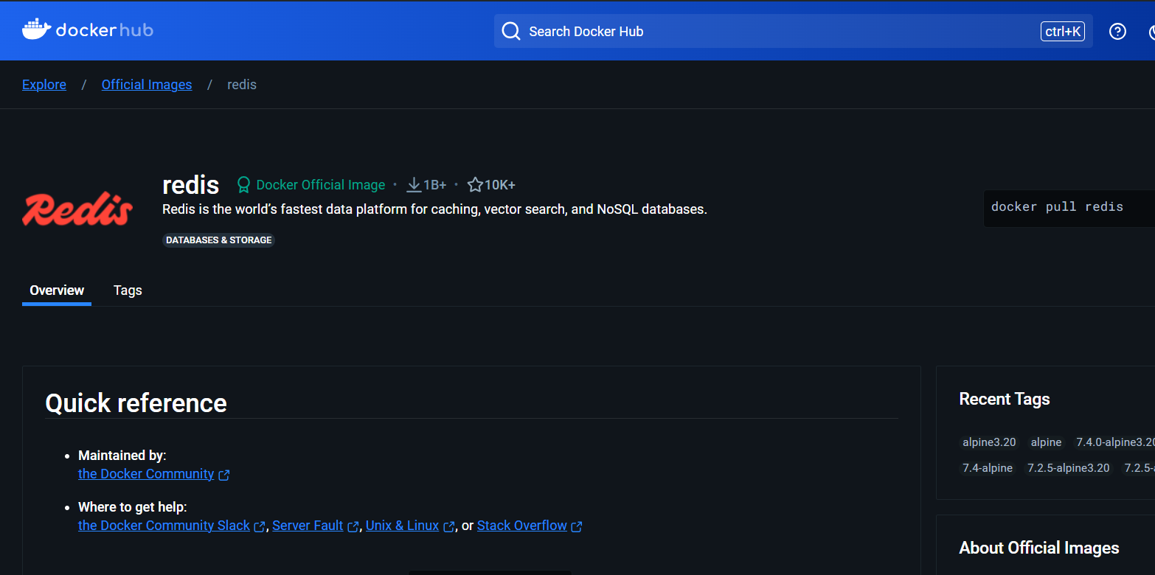
2. Run Docker Container of Redis Image in background  
   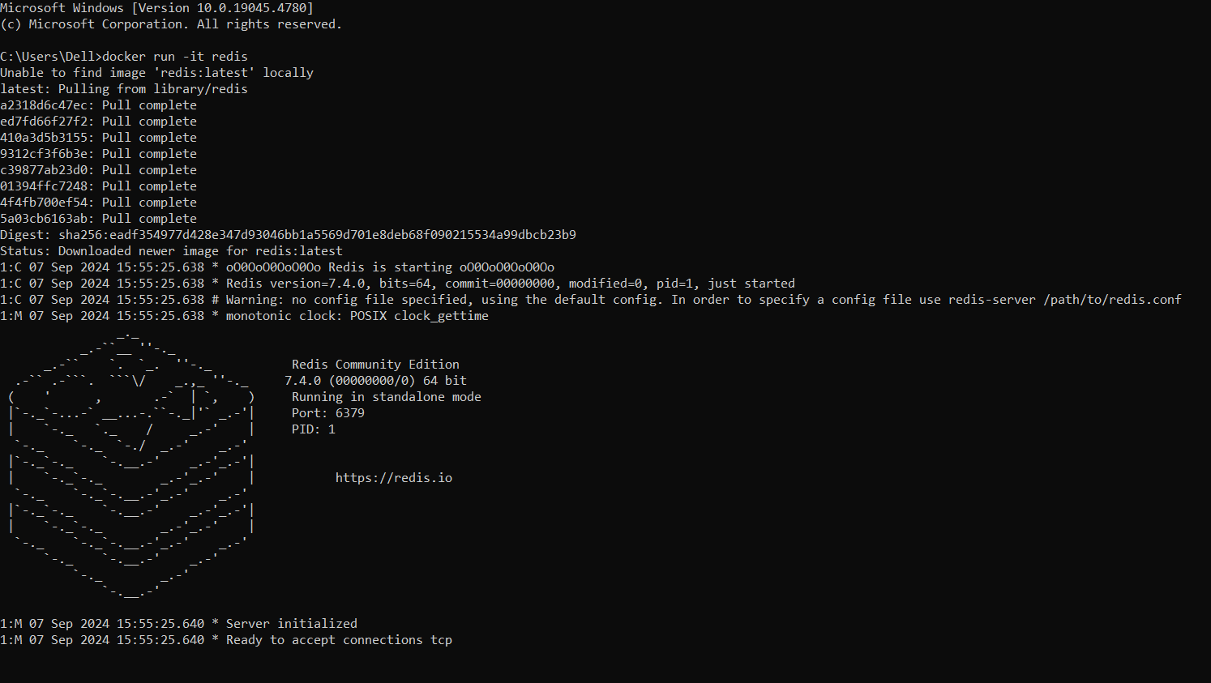
3. Run Docker PS and Docker PS –a  
   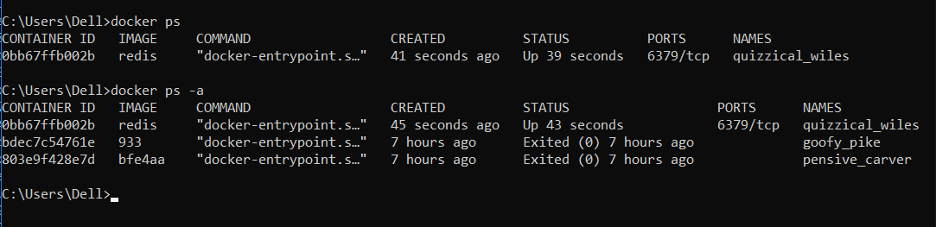
4. Run Docker Container and take its console  
   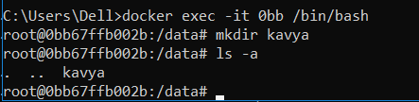
5. Create a Docker Volume and connect it  
   